Click or tap here to enter text.
Inclusion North Board of Directors.
Application Form




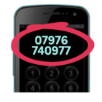
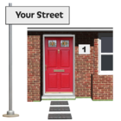


What is your name?
Click or tap here to enter text.

Where do you live?
Click or tap here to enter text.

What is your phone number?
Click or tap here to enter text.

What is your email address?
Click or tap here to enter text.

Tell us about the skills, knowledge and experience you have.


Click or tap here to enter text.

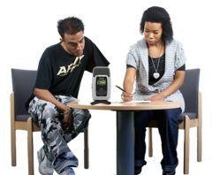
Please choose two people who can write you a reference. It should be people who know you well but not family or friends.

Name Click or tap here to enter text.
Address Click or tap here to enter text.

Phone number Click or tap here to enter text.
Email Click or tap here to enter text.
How you know them Click or tap here to enter text.

Name Click or tap here to enter text.
Address Click or tap here to enter text.

Phone number Click or tap here to enter text.
Email Click or tap here to enter text.
How you know them Click or tap here to enter text.

A DBS will be required for this role

Please return your form to us as soon as possible


info@inclusionnorth.org
0113 244 4792
Inclusion North
Unity Business Centre
26 Roundhay Road
Leeds
LS7 1AB

