Working together in County Durham so
people with a learning disability live a good life

People at Durham County Council have been thinking about how they might change the way they work to make sure people with a learning disability live a good life.

They have asked Inclusion North to work with the Council’s Engagement Team to find out what you think about their plans.

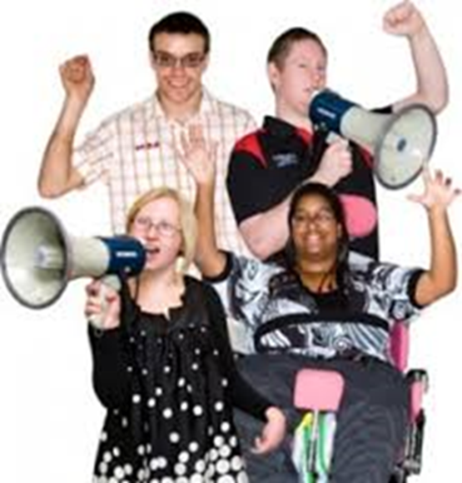 | Would you like to help to make sure  people with a learning disability  in County Durham live a good life?  If you do, please come along and  have your say.  Your views count!
 | When? Thursday 13th June
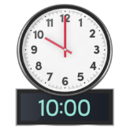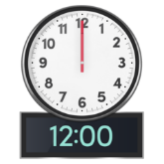 | What time?  10am – 12noon
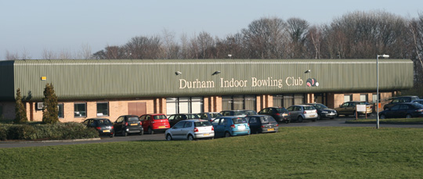 | Where?  Durham Indoor Bowling Club,  off Ryelands Way, Pity Me,  Durham, DH1 5GE  http://www.durhamibc.co.uk/howtofindus.php
It is important to book a place as space is limited.

Email: judith@inclusionnorth.org

Phone: 0113 2444792
http://bit.ly/2JnylbC

